**HIGHRADIUS INTERNSHIP REPORT**

**CONSULTANCY TRACK**

*Submitted by*

**Nivetha N**

(RA1811032010006)

*Under the Guidance of*

**Kayalvizhi Jayavel**

(Associate Professor, Department of Networking and Communication)

*in partial fulfilment for the award of the degree* of

**BACHELOR OF TECHNOLOGY**

in

**COMPUTER SCIENCE ENGINEERING WITH SPECIALIZATION IN INTERNET OF THINGS**

of

**FACULTY OF ENGINEERING AND TECHNOLOGY**



SRM Nagar, Kattankulathur – 603203, Chengalpattu District, Tamil Nadu

May 2022

**SRM INSTITUTE OF SCIENCE AND TECHNOLOGY**

(Under Section 3 of UGC Act, 1956)

**BONAFIDE CERTIFICATE**

Certified that this internship report titled is “HIGHRADIUS INTERNSHIP REPORT” the bonafide work of NivethaN**(RA1811032010006)** who carried out the internship work under my supervision. Certified further, that to the best of my acquaintance the work reported herein does not form any other project report or dissertation on the basis of which a degree or award was conferred on an earlier occasion on this or any other candidate.



## SIGNATURE OF GUIDE SIGNATURE OF HOD

KAYALVIZHI JAYAVEL DR. ANNAPURANI PANNAIYAPPAN K

Associate Professor Head of the Department

Department of Networking Department of Networking

And Communications And Communications

**Signature of Internal Examiner Signature of External Examiner**

**DECLARATION**

**Degree/ Course:** B Tech CSE IOT

**Student Name:** Nivetha N

## Registration Number: RA1811032010006

### Title of Work: HighRadius Internship

I hereby certify that this assessment compiles with the University’s Rules and Regulations relating to Academic misconduct and plagiarism, as listed in the University Website, Regulations, and the Education Committee guidelines.

I confirm that all the work contained in this assessment is my own except where indicated, and that I have met the following conditions:

* Clearly references / listed all sources as appropriate
* Referenced and put in inverted commas all quoted text (from books, web, etc.)
* Given the sources of all pictures, data etc. that are not my own • Not made any use of the report(s) or essay(s) of any other student(s) either past or present
* Acknowledged in appropriate places any help that I have received from others (e.g. fellow students, technicians, statisticians, external sources)
* Compiled with any other plagiarism criteria specified in the Course handbook / University website I understand that any false claim for this work will be penalised in accordance with the University policies and regulation.

🗹 I understand that any false claim for this work will be penalized in accordance with the University policies and regulations.

|  |
| --- |
| **DECLARATION:** |
| 🗹 I am aware of and understand the University’s policy on Academic misconduct and plagiarism and I certify that this assessment is my / our own work, except where indicated by referring, and that I have followed the good academic practices noted above. |
|  |



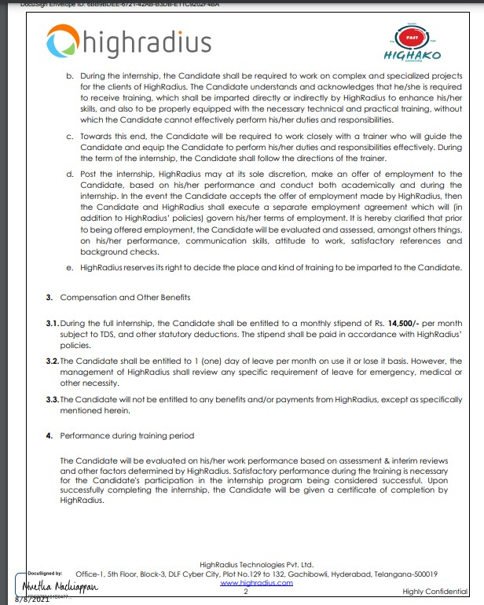

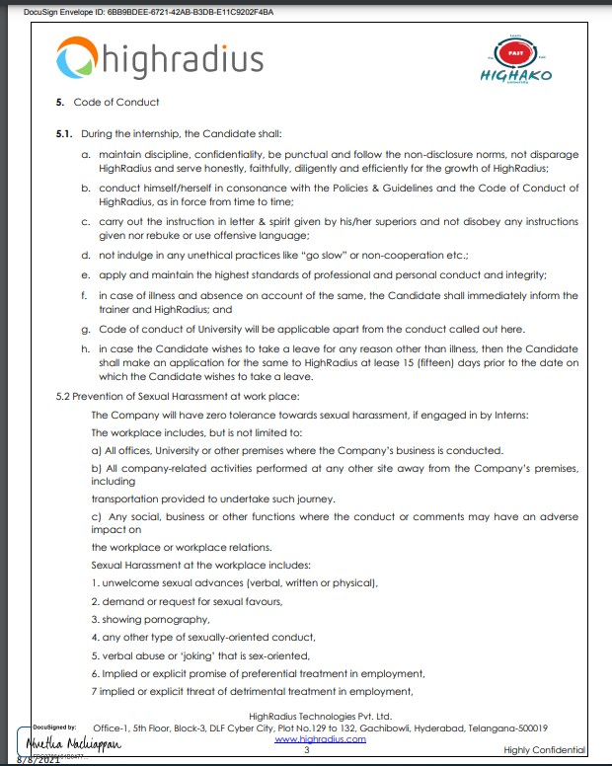

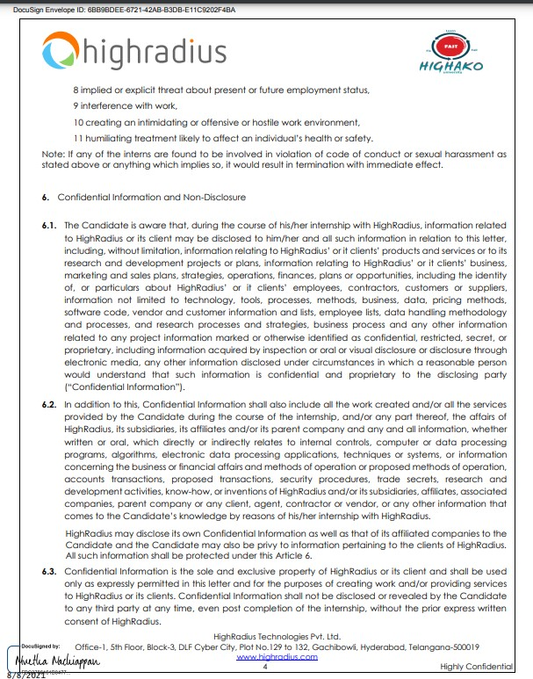

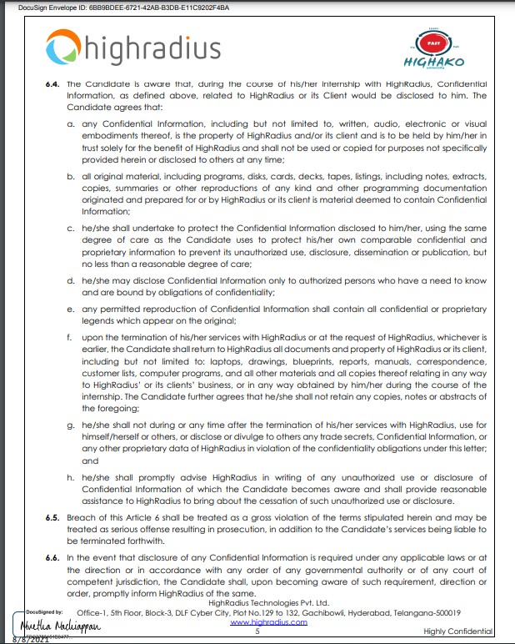

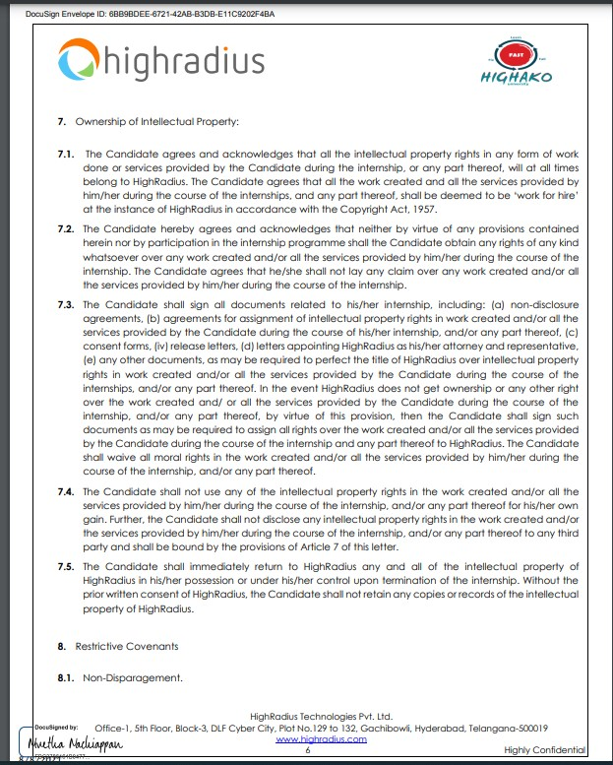

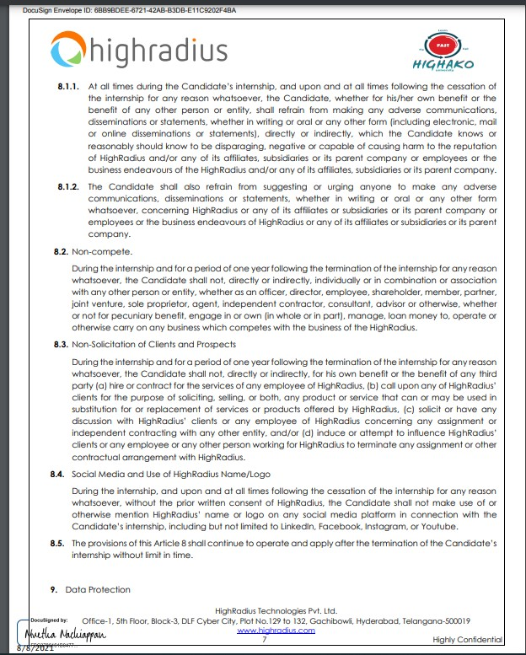

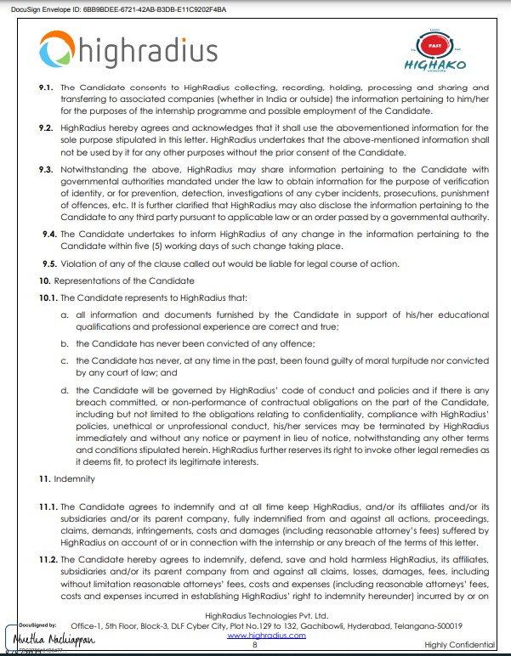

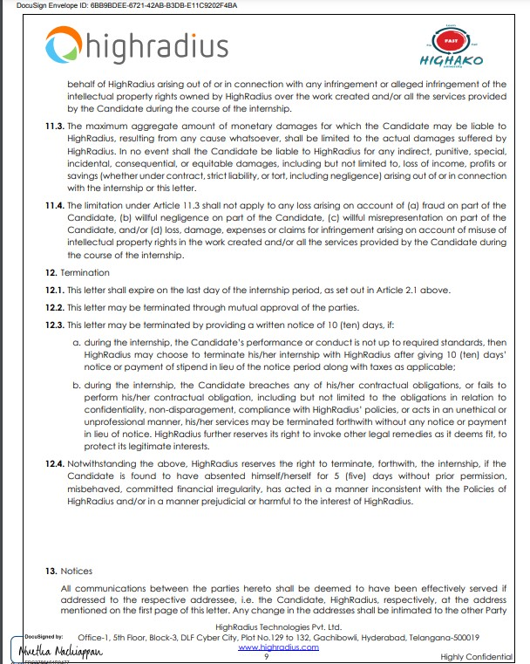

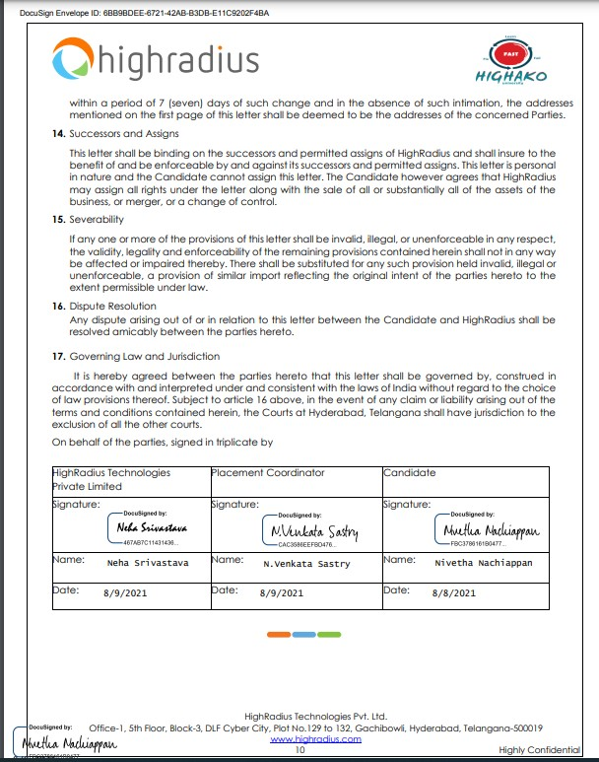

**ACKNOWLEDGEMENT**

We express our humble gratitude to **Dr C. Muthamizhchelvan**, Vice-Chancellor, SRM

Institute of Science and Technology, for the facilities extended for the project work and his continued support.

We extend our sincere thanks to Dean-CET, SRM Institute of Science and Technology, **Dr T.V. Gopal**, for his invaluable support.

We wish to thank **Dr Revathi Venkataraman**, Professor & Chairperson, School of Computing, SRM Institute of Science and Technology, for her support throughout the project work.

We are incredibly grateful to our Head of the Department**, Dr K. Annapurani**

**Panaiyappan** Professor, Department of Networking and Communications, SRM Institute of Science and Technology, for her suggestions and encouragement at all the stages of the project work.

We register our immeasurable thanks to our Faculty Advisor**, Prabhu Shankar C,** Assistant

Professor, Department of Computing Technologies, SRM Institute of Science and Technology, for leading and helping us to complete our course.

Our inexpressible respect and thanks to my guide, **Kayalvizhi Jayavel,** Associate Professor, Department of Networking and Communications, SRM Institute of Science and Technology, for providing me with an opportunity to pursue my project under his/her/their mentorship. She provided me with the freedom and support to explore the research topics of my interest. Her passion for solving problems and making a difference in the world has always been inspiring.

We sincerely thank the Networking and Communications Department staff and students, SRM Institute of Science and Technology, for their help during our project. Finally, we would like to thank parents, family members, and friends for their unconditional love, constant support, and encouragement.

Nivetha N

**ABSTRACT**

Bagging the HighRadius internship paved the way for self-growth and corporate learning. Though the process of bagging the internship was rigid and arduous, it helped improve my confidence. I was offered the role as a consultant intern for a yearlong period, starting from 9th August 2021 till 9th August 2022, which is still ongoing.

HighRadius is a SAAS company that offers cloud based autonomous software to ease the O2C process in B2B businesses. The company automates the receivables and payments of businesses through credit, electronic billing and payment processing, cash application, deductions and collections clouds.

As a consultant assigned to the collections cloud, I had to undergo a training period of one month before being assigned to a real time project. As per the norms of the software development life cycle, the work assigned was carried out in a systematic order helmed by the team lead, a full time experienced employee of the company.

The gist of my work includes the configuration of the UI based upon which the worklist of the business’s defaulters would be generated. The business now keeps track of the overdue payments and take necessary steps to make the defaulter pay for the services or goods already offered. HighRadius also leverages AI to decide on the action to be taken on the defaulter, thereby producing the desired result needed when it comes to extracting the overdue payments. Examples of actions decided upon include the payment of a fine, incessant calling, cold emailing the defaulter etc.

Having been founded in 2006 by Sashi Narahari, now the President and CEO of HighRadius, the company is now valued to be around three billion dollars. It has over 600 clients at present, out of which more than 200 of them are part of the Forbes Global 2000.

The company processes over one trillion dollars in transaction every year. Sashi Narahari has said the start-up’s success can be attributed to the company’s strong foundation on transparency, candour, perseverance and ownership.

Having just 3 months left for the internship to end, at the time of writing this report, I am utmost grateful for the experience I have gathered till date. I have learnt so much from teamwork, the importance of clear communication, posing confidence and most importantly, the ability to discipline myself into sitting in front of the laptop for 8-12 hours straight. The work life balance didn’t come into play at times because of the quality of work we had to deliver.

The internship, so far, has been going on in the online mode. We have been attending daily meetings with our team leads where we are briefed about the day’s work. Though I did miss out on making meaningful connections, it has proved to be an important starting point in the trajectory of my upcoming career where I would be able to apply my learnings and not repeat my mistakes.

It’s been a wonderful journey that I will cherish for life.

**TABLE OF CONTENTS**

CHAPTER NO. TITLE PAGE NO

## 1 WHY COLLECTIONS CLOUD 1-3

1.1 CHALLENGE

1.2 SOLUTION

1.3 KEY FEATURES

1.4 BENEFITS

1.5 ABOUT

## 2 ACCOUNTING BASICS USED IN WORK CYCLE 4-10

2.1 INTRODUCTION

2.2 TERMINOLOGIES USED

3 **BAGGING THE INTERNSHIP 11-13**

## 4 TRAINING PERIOD 14-15

4.1 IN MIDST OF THE TRAINING PERIOD

4.2 AFTERMATH OF TRAINING PERIOD

## 5 BRIEF OF MY WORK AS A CONSULTANT 16-35

5.1 HRC TOOLS

5.1.1 Connecting to VPN

5.1.2 Connecting to VDI

5.1.3 Connecting to Putty

5.1.4 Connecting to SQLyog

### 5.1.5 Connecting to FileZilla

5.2 CONFIGURING THE UI

5.3 AGENTS AND DATABASE

5.3.1 Introduction to Agents

5.3.2 Types of ETL agents

### 5.3.3 Types of Non-ETL agents

5.3.4 Main common agent configuration tables

5.3.5 Order of Configuring the tables for the agents

5.3.6 Running the agents

### 5.4 GENERATION OF WORKLIST

1. **OTHER CLOUDS MEANT FOR LARGE ENTERPRISE 36-40**
   1. INTRODUCTION TO SERVICES PROVIDED
   2. CREDIT CLOUD
   3. EIPP CLOUD
   4. CASH APP CLOUD
   5. DEDUCTIONS CLOUD
   6. SIDE NOTE ABOUT COLLECTIONS CLOUD

7 **CONCLUSION 41-42**

* 1. SPECIAL MENTIONS
  2. NOTE TO SELF

**LIST OF FIGURES AND TABLES**

Figure 1.2.1 Overview of the Collections Cloud…………………………………….2

Figure 3.1 Google Form Application forwarded the 2nd time around………………..11 Figure 3.2 O2C Diagram from YouTube module……………………………………12

Figure 3.3 B2B Diagram from YouTube module……………………………………13

Figure 3.4 Excel Assignment Sample………………………………………………..13

Figure 4.1.1 Modules………………………………………………………………...14

Figure 4.1.2 Inside a Module…………………………………………………………15

Figure 5.1.1.1 The screen after connecting to the VPN………………………………16

Figure 5.1.1.2 The app that allows us to connect to the VPN………………………...16

Figure 5.1.2.1 Options to either launch from client or browser……………………….17

Figure 5.1.2.2 VDI launched from client………………………………………………17

Figure 5.1.3.1 Putty Configuration…………………………………………………….18

Figure 5.1.3.2 Putty Connection……………………………………………………….18

Figure 5.1.4.1 Database view…………………………………………………………..19

Figure 5.1.5.1 FileZilla Interface……………………………………………………….19

Figure 5.2.1 Design Sheet Template……………………………………………………20

Figure 5.2.2 Configuring the ECI Source System………………………………………20

Figure 5.2.3 Snippet of UI Headers for Collections Cloud……………………………..22

# Figure 5.2.4 Configuring Strategies…………………………………………………….22

# Figure 5.3.5.1 Flowchart of Table configuration for Agents…………………………..29

# Figure 5.3.6.1 Preview of a ram request query in bouncer………………………………34

# Figure 5.4.1 Snippet of the worklist generated for Thomson Reuters company………...35

# Figure 6.1.1 HighRadius Products available as of today………………………………...36

# Figure 6.1.2 Autonomous Finance for the office of CFO………………………………..37

# Figure 6.2.1 Credit Cloud Features……………………………………………………....37

# Figure 6.3.1 EIPP Cloud Features………………………………………………………..38

# Figure 6.4.1 Cash App Cloud Features…………………………………………………..39

# Figure 6.5.1 Deductions Cloud Features………………………………………………....40

# Figure 6.6.1 Collections Cloud Features………………………………………………….40

# Figure 7.1.1 Geetika Batra, Training Period Mentor……………………………………..41

# Figure 7.1.2 Ayesha Mogal, Project Mentor……………………………………………..41

**LIST OF SYMBOLS AND ABBREVIATIONS**

SAAS - Software as a Service

O2C – Order to Cash

B2B – Business to Business

AI – Artificial Intelligence

UI – User Interface

DSO – Days Sales Outstanding

POD – Payable on Death

ERP – Enterprise Resource Planning

IT – Information Technology

VPN - Virtual Private Network

VDI – Virtual Desktop Infrastructure

FTP – File Transfer Protocol

CFO – Chief Financial Officer

URL – Uniform Resource Locator

**CHAPTER 1: WHY COLLECTIONS CLOUD**

**1.1 CHALLENGE:**

Considering the critical nature and direct value that collections improvements provide to a business looking to grow, it is surprising that many collections teams still rely on manual processes and spreadsheets to manage dunning activities. This lack of automation and optimization inhibits teams from keeping up with increases in past due balances, impedes productivity and efficiency, hurts customer service and negatively impacts cash flow, Days Sales Outstanding (DSO), and equity. It also creates a lack of visibility into the collections process and individual collector results. A lack of data to sufficiently prioritize collector activity combines with the manual work required to research and contact accounts to result in major staff inefficiency.

**1.2 SOLUTION:**

HighRadius Collections Cloud provides a complete set of tools to optimize and automate the collections process and enable the better prioritization of collections activities. All the information you need (invoices, dispute information, POD, claims, tracking info, etc.) on each case is automatically presented in a collections workspace and ready for use. With a prioritized worklist, driven by pre-defined business rules, backup information readily available, and automated dunning correspondence, collectors are able to contact more accounts and centrally track the activity for review and follow-up. The result is a more efficient collections team that contributes to enhanced cash flow and reduced DSO.

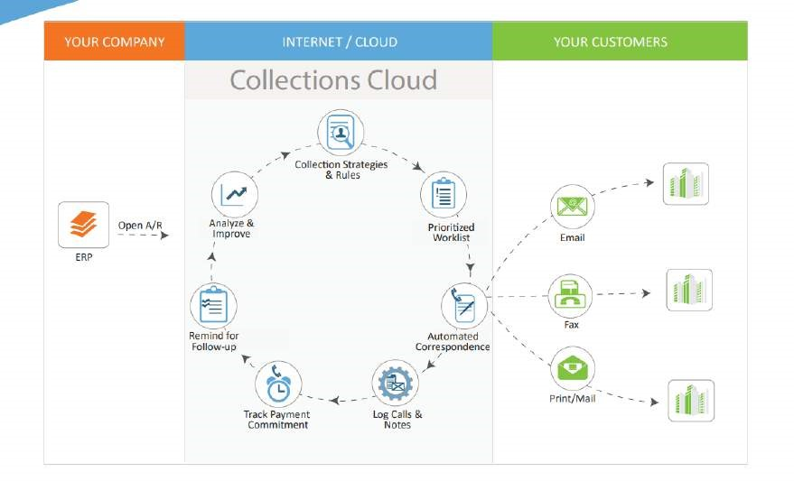

## Figure 1.2.1 Overview of the Collections Cloud

**1.3 KEY FEATURES:**

* Rules-based Collections Optimization automatically prioritizes and assigns collections activities to analysts based on pre-defined business rules.
* Integrated Collections Workspace tracks promises-to-pay, tasks and reminders for every account and collection effort.
* Predictive Risk Scoring Model identifies ‘at-risk’ customers who might be current on their account and integrates the risk level into prioritization.
* Dunning Correspondence Automation generates and sends out correspondence packages containing needed documentation based on pre-defined templates.
* Easy integration with ERP, Accounting, and other systems.

**1.4 BENEFITS:**

* Increase collector efficiency by up to 30%, freeing up time to focus on higher value activities.
* Reduce Days Sales Outstanding (DSO) by 10%.
* Reduce bad debt write-offs and operating costs.
* Standardize process to rank and manage collections activities.
* Enable reduction of risk. - Limit upfront capital expenditure and minimize the need for internal IT involvement by using a “pay-as-you-use” SaaS solution with a monthly subscription fee.

**1.5 ABOUT:**

HighRadius Collections Cloud automates and optimizes the collections process to improve collector efficiency, minimize bad debt write-offs, improve customer relationships and reduce DSO. A cloud-based solution available as Software-as-a-Service, Collections Cloud is easy and cost-effective to deploy and maintain.

**CHAPTER 2: ACCOUNTING BASICS USED IN WORK CYCLE**

* 1. **INTRODUCTION:**

Basic accounting normally includes the areas of Debits and Credits; Accounts; Assets, Liabilities, Equity, Revenue and Expenses; and, an accounting system that offers a method for checking, balancing, and reconciling all accounting related transactions in order to produce accurate pictures of the entities financial health. Profit and Loss Reports, Balance Sheets, and Cash Flow Statements are the end result of compiling all the transactions into meaningful, usable information for individuals and business owners alike.

* 1. **TERMINOLOGIES USED:**

1.Account Receivables: The amount of money owed by customers or clients to a business after goods or services have been delivered and/or used.

1. Accounts Payable: The amount of money a company owes creditors (suppliers, etc.) in return for goods and/or services they have delivered.
2. Promise to Pay(P2P): is a type of payment arrangement and a commitment to pay a certain amount by a specific date to prevent collections activity.
3. Broken Promise to Pay(P2P): When the client or customer breaks the promise that they did to pay a certain amount by a specific date.
4. Bad Debt: is an expense that a business incurs once the repayment of credit previously extended to a customer is estimated to be uncollectible.
5. Assets: any resource that can be owned or controlled to produce value and that is held by a company to produce positive economic value is an asset. Ex: bonds, cash, real estate’s etc.
6. Liability: is a debt owed by a company that requires the entity to give up an economic benefit (cash, account payable etc.) to settle past transactions or events.
7. Working Capital: The capital of a business which is used in its day-to-day business operations, calculated as the current assets minus the current liabilities.
8. Remittance Document: is a document sent by a customer, which is often a financial institution or another type of firm, to a creditor or supplier along with payment to briefly explain what the payment is for so that the customer's account will be credited properly.
9. Lockbox: is a bank-operated mailing address to which a company directs its customers to send their payments. The bank opens the incoming mail, deposits all received funds in the company's account, and scans the payments and any remittance information.
10. Purchase Order: sent by the customer to the company enquiring to buy the goods.
11. Sales Order: Sent to customer before delivering good or service in response to the purchase order client.
12. Invoice: list of goods sent or services provided, with a statement of the sum due for these; a bill.
13. Proof of Delivery (POD): functions like a receipt to prove that a delivery had been completed and the recipient received the contents send by the sender.
14. Claims: is basically legal demand by the customer for compensation, payment or reimbursement for a loss under contract or received damaged goods.
15. Deduction: Is the amount not paid by the customer, less than specified in invoice because of related issue with goods received.
16. Prospect: Anyone we are talking to who is yet to be a customer.
17. Freight charges: Charge of shipping the goods from producer to consumer/customer. 19. Cash Flow: is the net amount of cash and cash-equivalents being transferred into and out of a business.
18. Income Statement: aka Profit and Loss statement is financial statement that reports financial performance of a company over specific period of time.
19. Account Statement: is the Periodic Summary of an activity in past period of time like Bank Statement, Transactional level statement.
20. Non-Performing Asset (NPA): is a loan or advance for which the principal or interest payment remained overdue for a period of 90 days or more.
21. Net Present Value (NPV): Difference between present value of cash inflow and present value of cash outflow over a period of time. NPV (+): Revenue increases NPV (-): Revenue

Decreases

1. Days of Sales Outstanding (DSO): Number of days it takes a company to collect cash from its credit sales.
2. Day Inventory Outstanding (DIO): number of days it takes for inventory to turn into sales. The average inventory days outstanding varies from industry to industry, but generally a lower DIO is preferred as it indicates optimal inventory management.
3. Days Payable Outstanding (DPO): Is a financial ratio that indicates the average time (in days) that a company takes to pay its bills and invoices to its trade creditors, which include suppliers, vendors or other companies.
4. Cash Conversion Cycle (ccc): Length of time it takes a company to convert its input resource into cash flow.

CCC=Days Inventory Outstanding (DIO) + Days sales outstanding (DSO) – Days Payable Outstanding (DPO)

1. Net Profit: Is the actual profit after excluding every working expenses of the company, does not include gross profit.

Net Profit = Total Revenue – Total expenses Paid (capex +opex) (OPEX) is an expense required for the day-to-day functioning of a business while (CAPEX) is an expense a business incurs to create a benefit in the future

1. Gross Profit: Is the profit a company makes after deducting the costs associated with making and selling its products.
2. Write-Offs: Asset determined to be uncollectable or considered loss by the company. 31. Trade Promotions: Are the various incentives provided to your distribution channels or customers in form of discounts, offering demonstrations, exhibitions etc.
3. Liquidity: Assets of a company which can be easily converted into cash.
4. General Ledger: Technically a book of set of numbers, an accountant of business uses to keep track of the financial transaction and to prepare financial report of the company. 34. Credit Bureau: Are companies or institutions which collects and researches individual credit info, sell it for a fee to creditors so that those creditors can make a decision on granting loans.

Ex: TransUnion, Equifax

1. Overdue Invoices: bills of exchange, loans and other obligations still unpaid past their due date.
2. Subsidiary: In the corporate world, a subsidiary is a company that belongs to another corporation or company, which is usually referred to as the parent or the holding company.

The parent holds a controlling interest in the subsidiary company, meaning it has or controls more than half of its stock.

1. Parent Child Hierarchy: Parent company is basically the head company while all its subsidiaries or branch of that company can be defined as Child companies. Now those child companies may provide the bill address as its parent company which will pay for all of the invoices of its respective child companies. This is basically a Parent Child Hierarchy.
2. Benchmarking: Is the process of comparing one’s business process and performance metrics to industry’s best.

Ex: ISO9001

1. Weighted Average Cost of Capital (WACC): is the rate that a company is expected to pay on average to all its security holders to finance its assets. The WACC is commonly referred to as the firm's cost of capital.
2. Days Deduction Outstanding (DDO): Metrics used to calculate number of days it takes for a company to handle and close all its outstanding deductions.
3. Credit Risk: Probable risk of losing the asset/money loaned to borrower as a result of borrower failing to repay.
4. Credit Score: Is the statistical number to evaluate customer credit worthiness. 43.

Liquidity Ratio: Measurement of company’s ability to pay of its current debt or obligations using its near cash or quick assets.

1. Billing Cycle: is basically the interval time between two bills.
2. Net Recovery Rate: Is the rate or extent to which principal amount and interest on defaulted debt can be recovered. It is always on BAD DEBT.
3. Aging: Classifies clients open AR on days’ basis (1-30, 31-60,61-90 days)
4. Return on Investment (ROI): is basically ratio of net profit to cost of investment.
5. Bill of Lading (BOL): is legal document between shipper and freight carrier like type of good, quantity and destination of goods.
6. Gross Margin: Difference between Revenue and cost of good divided by Revenue. Gross

Margin= (revenue-cost of good)/revenue

1. Dunning Letter: A reminder letter sent by lender to the borrower notifying them their over dues.
2. Credit Memo: Let’s say a customer pays 200$ more than they have to pay, so the client will issue a credit memo of 200$ in the name of that customer basically meaning that customer can buy goods worth 200$ in the nearby future without paying or deducted from the next bill.
3. Debit Memo: Is basically opposite of credit memo. If a customer pays X$ less that what they have to pay mainly because of deductions, client will issue debit memo of X$ basically meaning that customer defaults on X$ and those X$ will be added in the next bill.

Ex: PepsiCo(Seller) Big Bazaar(Buyer)

If PepsiCo sells goods worth 1CR to BB on credit and BB pays PepsiCo with 0.5 CR more.

PepsiCo owes the debit of 0.5CR to BB.

1. ACH (Automated Clearing House): is an electronic funds-transfer system run by NACHA, formerly the National Automated Cleaning Housing Association, since 1974. This payment system deals with payroll, direct deposit, tax refunds, consumer bills, tax payments, and many more payment services in the United States.
2. Wire: is a method of electronic funds transfer from one person or entity to another. A wire transfer can be made from one bank account to another bank account or through a transfer of cash at a cash office.

**CHAPTER 3: BAGGING THE INTERNSHIP**

I remember missing the chance to apply for the internship first time around as I was down with covid. Many of my classmates had qualified for the internship training period and were relieved of having something in hand while pursuing for other companies' entrance exams. I was angry at having missed an opportunity when suddenly, as God's call, there was another chance to apply for the business role that came in the class WhatsApp group. I quickly applied through a Google form after which we were called for a brief testing period of our skills on excel, guesstimates and PowerPoint. Those who excelled were given the chance to actually bag the 1-year long internship and start the training.

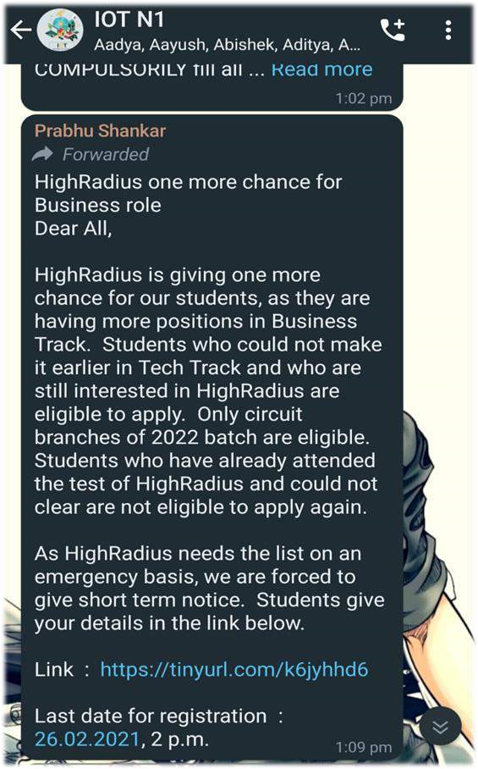

## Figure 3.1 Google Form Application forwarded the 2nd time around

From the start of the testing period, I was under the impression that HighRadius was a company with high expectations on quality work deliverance and time management. They had prepared modules comprising YouTube videos and reference notes which we had to go through before moving on to complete the day's assignments based on what we had learnt that day.

The YouTube videos was based upon excel shortcuts, guesstimates and case scenarios demanding solutions. The assignments drilled on our analytical, logical and presentation skills. We also got to learn about general concepts like the 02C cycle, billing and B2B business which their company was based upon.

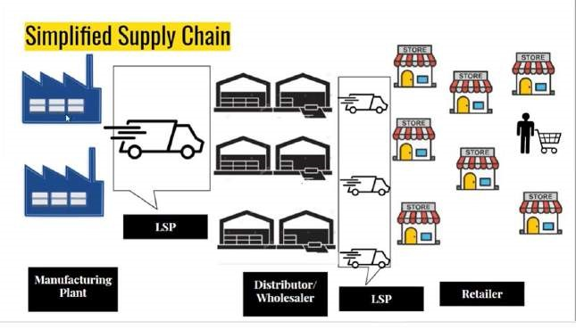

## Figure 3.2 O2C Diagram from YouTube module

After 2 weeks, there was a one on one interview on what we had learnt so far which I was able to ace to qualify for the internship. For the first time, even in those 2 weeks, I had been introduced into the corporate world where I had to be curious, ask questions boldly and most importantly have the hunger to complete the tasks with 200 percent conviction.

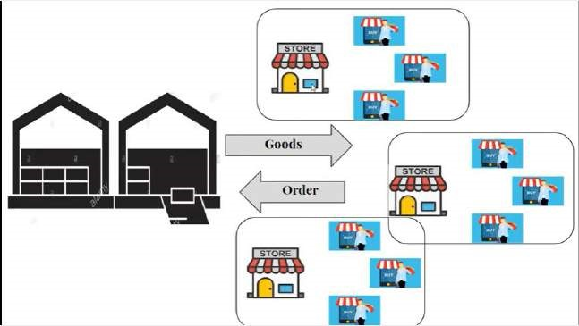

## Figure 3.3 B2B Diagram from YouTube module

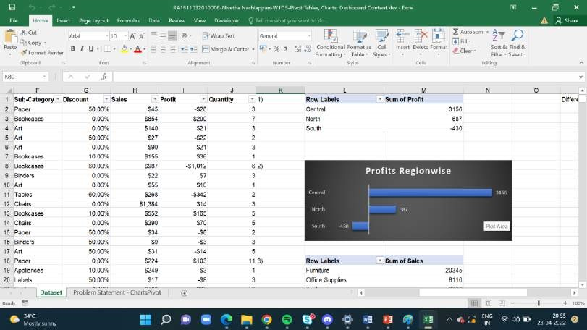

# Figure 3.4 Excel Assignment Sample

**CHAPTER 4: TRAINING PERIOD**

## 4.1 IN MIDST OF TRAINING PERIOD

The training period comprised of 30 learning modules which spanned over a month. Each working day, we had a call in the morning to brief us what we had in store for the day. We also had a schedule to look through 5 hrs worth of videos and a call at the end of the day to clear our doubts with our mentors.

All the interns were also divided into groups of three to work hands on and gather experience. By hands on experience, I meant we had to work on the dummy version of a real time mini project. We also had weekly vivas in that month which were scary and difficult but they helped us strengthen our basics and instil confidence.

The mentors assigned to groups of 8 interns were ever ready to help with our queries which served as a great morale booster.

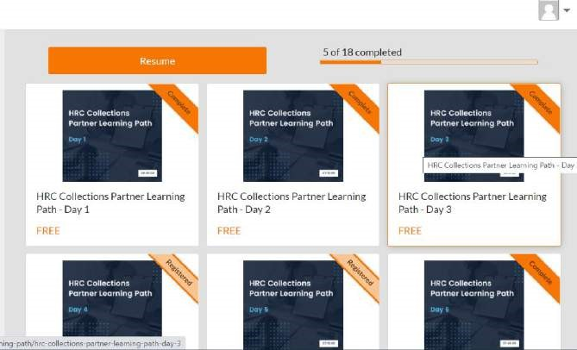

**Figure 4.1.1 Modules**



**Figure 4.1.2 Inside a Module**

## 4.2 AFTERMATH OF TRAINING PERIOD

After a month of training, all the interns in the consulting stream were divided into batches of 2 and assigned real time projects under the supervision of a guide.

The time of assignment to a real time project depended on the scores on the virtual leader board till then. I was assigned to be a techno functional consultant for the collections cloud, the cloud which will help aid the collection of overdue invoices of our clients' clients.

Also, I was one of the first few ones to be assigned to a project soon after the training had ended.

The initial days were difficult and we had to pester our guide with questions which she patiently answered.

We had our calendars marked with various meetings every day, checking on the progress of the previous days’ work and also on the issues/ technicalities that rise in the midst of the work.

**CHAPTER 5: BRIEF OF MY WORK AS A CONSULTANT**

## 5.1 HRC TOOLS

### 5.1.1 Connecting to VMware VPN

In order to access the data and the UI on which we would have to work upon, we would first have to connect to the VPN.

A VPN establishes a protected network for the company and encrypts the internet traffic.

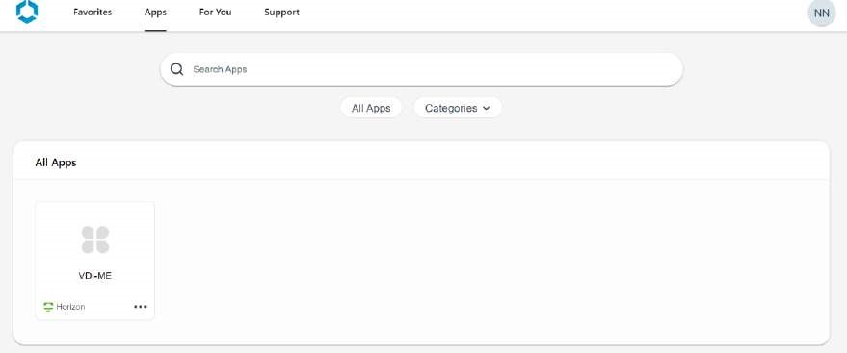

# Figure 5.1.1.1 The screen after connecting to the VPN



**Figure 5.1.1.2 The app that allows us to connect to the VPN**

5.1.2 Connecting to the VDI

Next we have to connect to the VDI to work on whatever we have to work on.

A VDI is a desktop that is virtualised. A VDI hosts numerous desktop environments on a centralized server and deploys them to each user who requests for it.

The VDI can be launched from the client or browser as shown in the figure below.

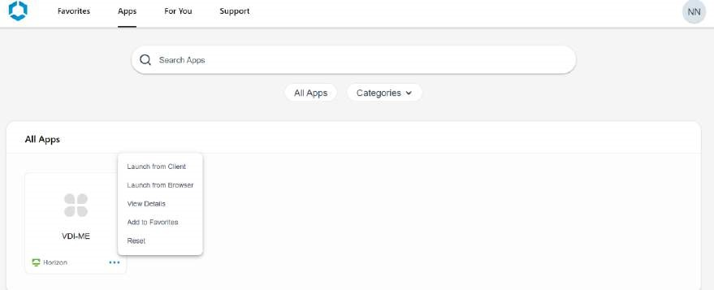

### Figure 5.1.2.1 Options to either launch the VDI from client or browser

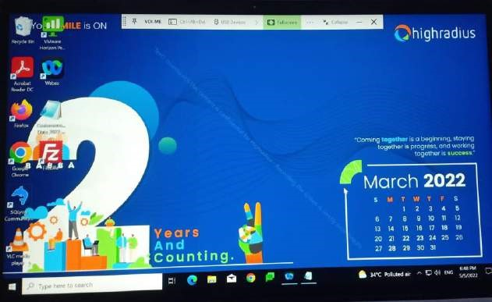

**Figure 5.1.2.2 VDI launched from client**

#### 5.1.3 Connecting to Putty

Putty is an open source terminal emulator that manages and configures devices from the PC.

It supports network protocols like SSH and Telnet primarily.

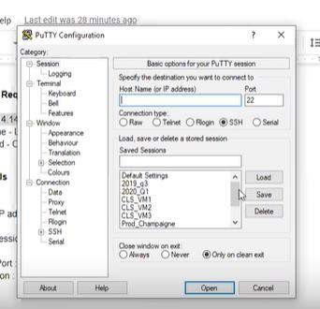

### Figure 5.1.3.1 Putty Configuration

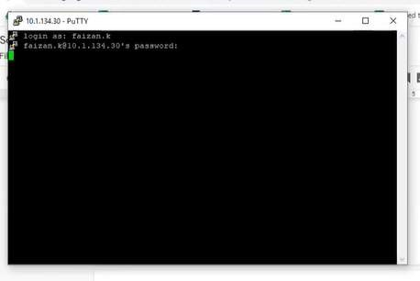

### Figure 5.1.3.2 Putty Connection

#### 5.1.4 Connecting to SQLyog

SQLyog is the database exclusively used to store all the clients’ data in tables.

We use the normal syntax of SQL commands to retrieve and make changes to the data.

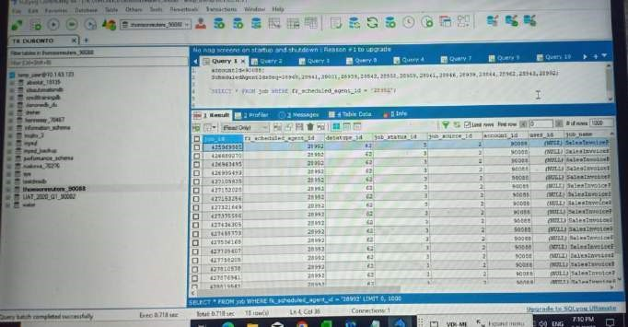

### Figure 5.1.4.1 Database view

#### 5.1.5 Connecting to FileZilla

FileZilla is a utility that is used to transfer files, here particularly the business’s clients’ data from a remote computer by FTP.

The inbound folder contains the data to be loaded and the outbound folder contains the data that has been loaded.

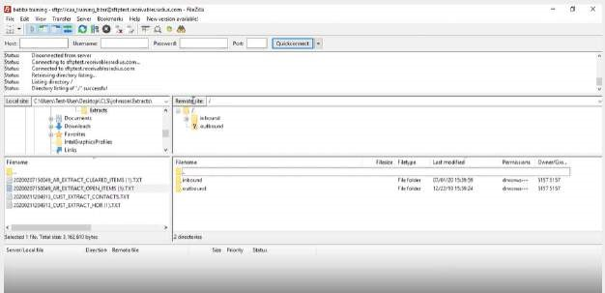

**Figure 5.1.5.1 FileZilla Interface**

## 5.2 CONFIGURING THE UI

First, the brainstorming of the necessary configurations conforming to the client’s needs is undertaken by the architect team. Everything brainstormed is put into an excel sheet and is passed on to the consultants as shown in the figure below.

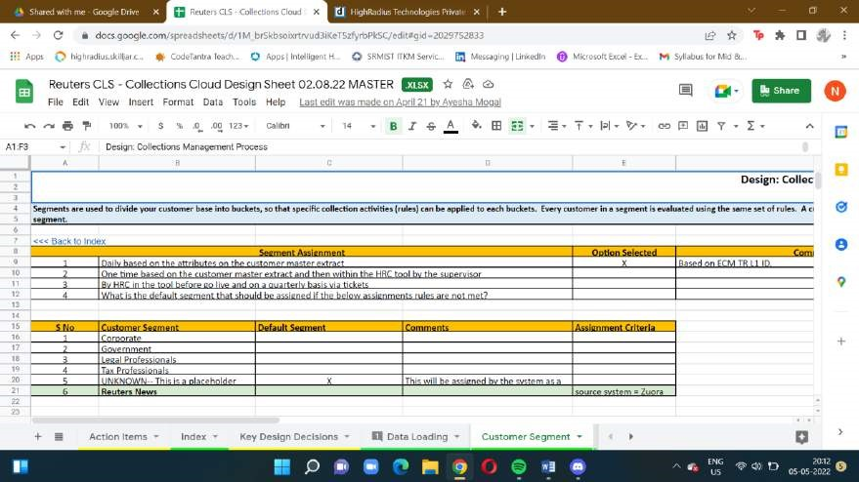

### Figure 5.2.1 Design Sheet Template

Next, we set up the ECI source system for the business which is synonymous to laying the ground when constructing a building.

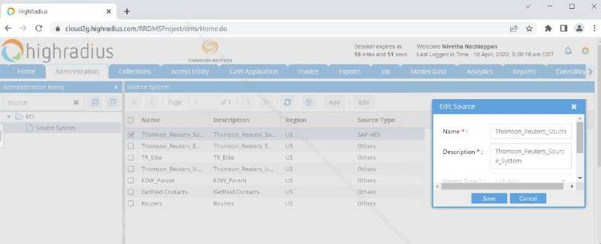

**Figure 5.2.2 Configuring the ECI Source System**

After the source system is set up, we configure the necessary configurations as directed by the design sheet.

Some of the main configurations that are done for each client are:

1. Aging Buckets – This feature groups the number of days an invoice has been overdue into ranges called buckets.

1. Priorities – This feature assigns the priorities to the overdue invoices that have to be followed up

1. Recipient roles –Internal and external contacts are configured.

1. Communication Reasons – As evident from the title, this feature provides reason as to why the particular communication is happening.

1. Customer and Invoice Tags – Tags are created on invoices and customers so that the search for them in the worklist is easier.

1. Segmentation – The client’s customers are divided into segments based on assignment rules or AI.

1. Follow-Up Task Reasons – When a client’s customer promises to pay on a later date, a follow up task must be set up for that client. There are many more other scenarios for which different types of follow up reasons are configured.

1. Dispute Reasons – When a client’s customer raises a dispute in the bill saying one of the items in there has not been delivered or an extra item has been billed for which the purchase has not been made, a dispute reason must be set up for that invoice. There are many more other scenarios for which different types of dispute reasons are configured.

1. Actions – They are assigned to each customer based upon factors like the number of past due days, previous payment history etc.

1. Strategies – Customers are grouped into different strategies where actions are assigned to each strategy. These actions can be rule based or score based that are premediated in the design sheet. Priorities for those actions are also assigned in each strategy.
2. Correspondences – They are configured to be sent out to the defaulters and the business logos are mapped to these correspondences.

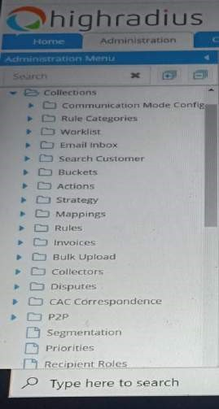

### Figure 5.2.3 Snippet of UI Headers for Collections Cloud

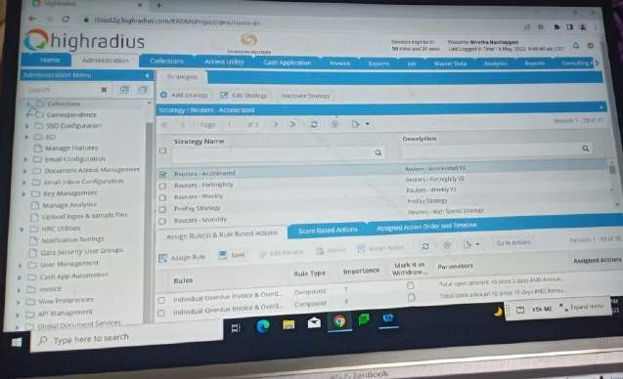

**Figure 5.2.4 Configuring Strategies**

**5.3 AGENTS AND DATABASE**

### 5.3.1 Introduction

An agent is a virtual machine that runs all jobs.

There are two type of agents namely ETL and Non-ETL agents.

ETL agents extract, transform and load data of the client’s customers.

Non-ETL agents follow up on assigning, strategy evaluation etc.

Agents are configured in tables in SQLyog.

### 5.3.2 Types of ETL agents

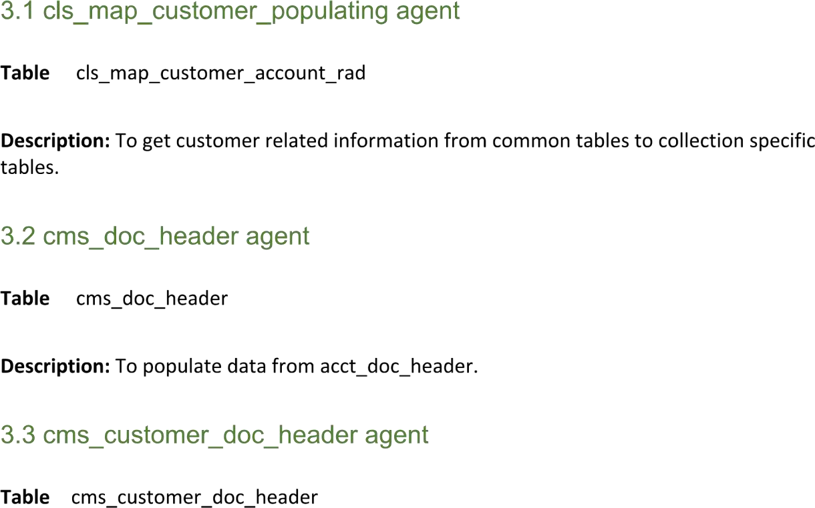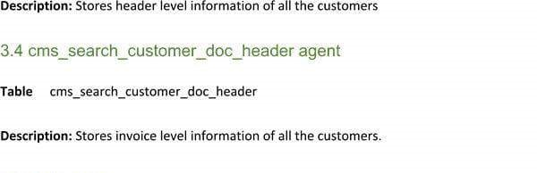

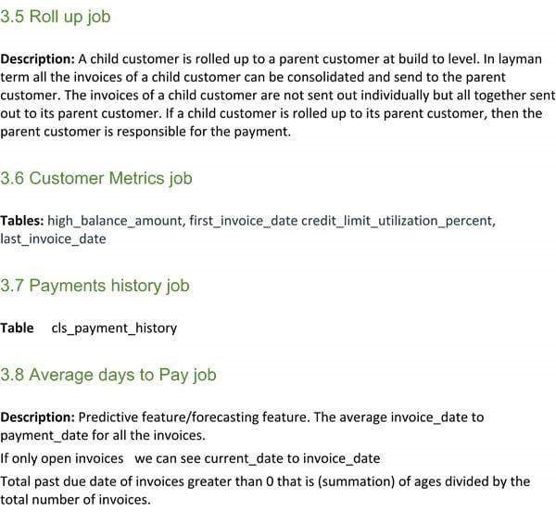

### 5.3.3 Types of Non-ETL agents

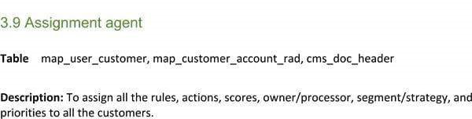



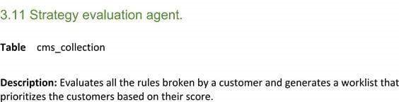

### 5.3.4 Main common agent configuration tables

1. Service Provider Table

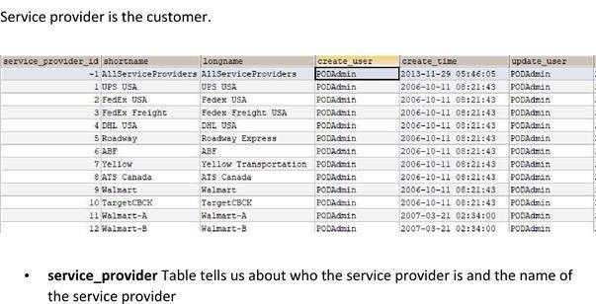

1. Data provider Table

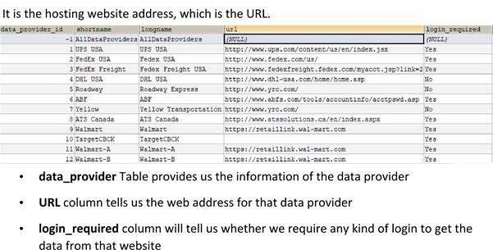

1. Provider Datatype Table

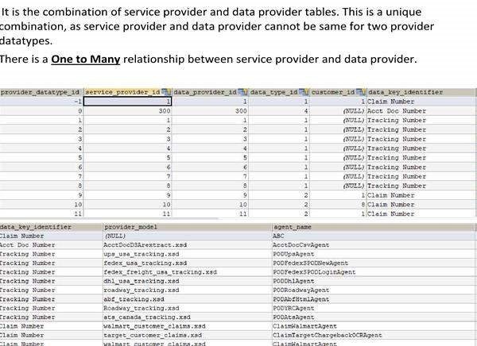

1. Account Provider Datatype table

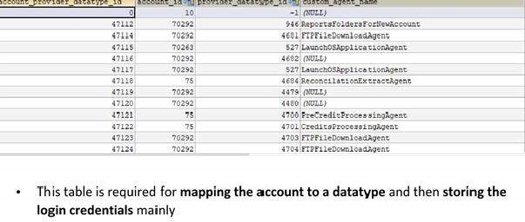

5.Account Provider Datatype Auto Table

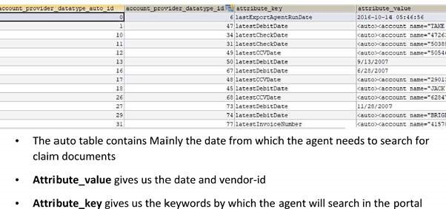

6.Account Provider Datatype Auto Config Table

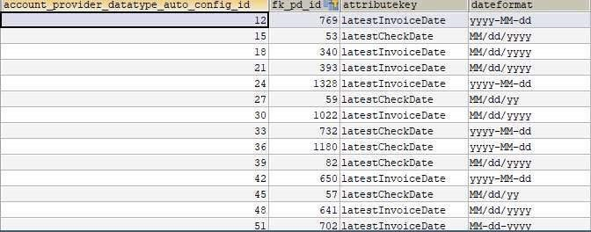

7.Account Provider Datatype Config Table

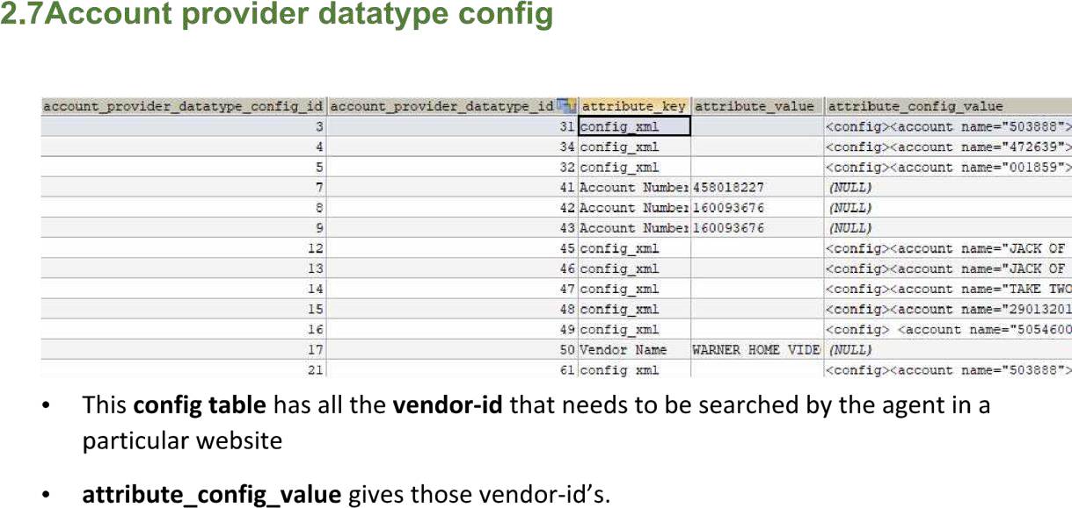

8.Account Provider Datatype Process Config Table

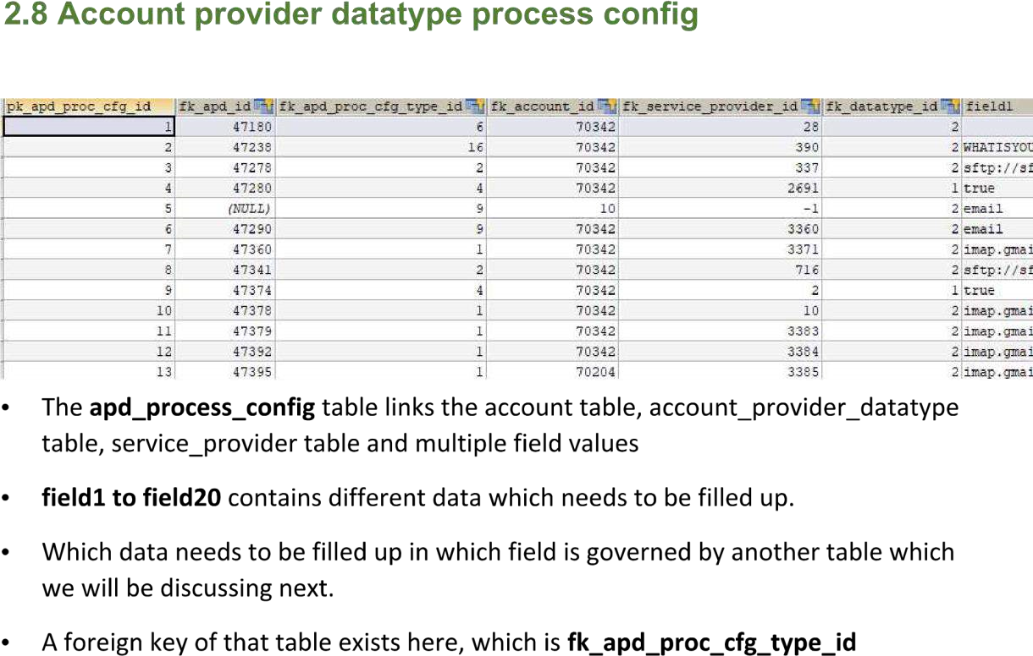

9.Account Provider Datatype Process Config Type Table

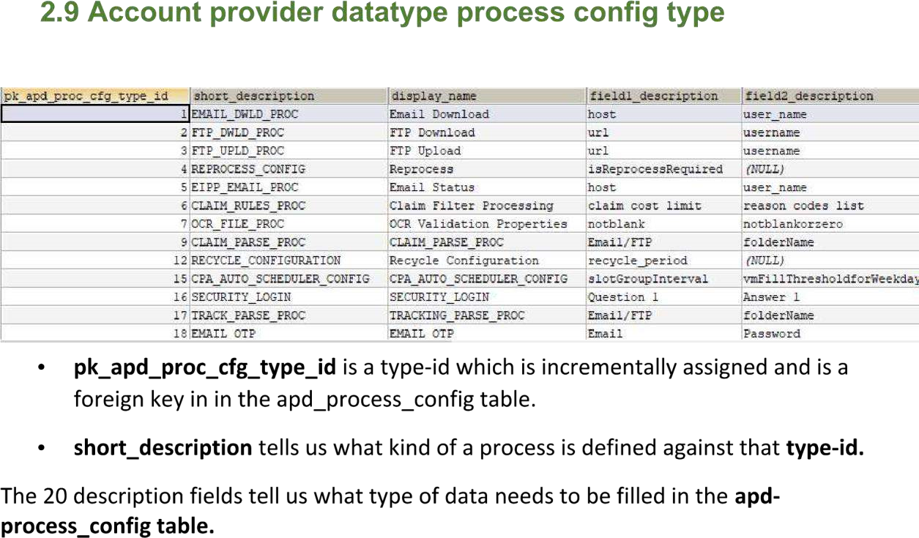

### 5.3.5 Order of Configuring the tables for the Agents

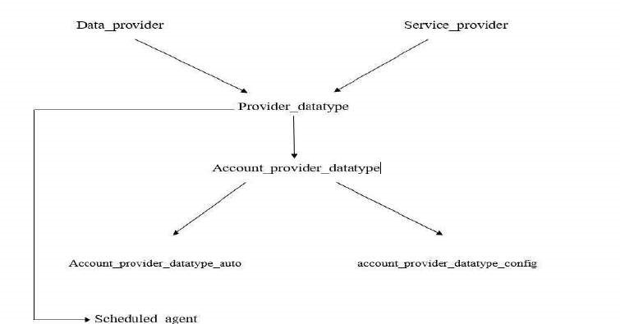

**Figure 5.3.5.1 Flowchart of Table configuration for Agents**

Following are the SQL commands in order and with explanation used in the configuration of an agent for EDW_Customer for Thomson Reuters Company, citing the following commands as an example to configure an agent:

### -SELECT * FROM map_query_report WHERE fk_account_id='90088';

‘@fromDate@’ is there in the query string for EDW_Customer, thus account_auto TABLE has to be updated as well for file generation agent.

### -SELECT * FROM scheduled_agent WHERE fk_account_id='90088';

DMSAgentProcessor is the file generation agent.

FileUpdateAgentProcessor is the file upload agent.

In the configs column for the above two agents, providerDataTypeIds are present.

The above two agents are present for EDW_Customer.

28647,28657 are the respective scheduled_agent_ids for those two agents.

Filtering the config column respectively with the scheduled agent ids, the WrapperAgentProcessor is not configured.

Checking whether the DMSAgentProcessor and FileUpdateAgentProcessor are properly configured FOR EDW_Customer:

FOR FILE upload agent, working backwards:

**-SELECT * FROM provider_datatype WHERE provider_datatype_id=13382;**

### -SELECT * FROM data_provider WHERE data_provider_id=6506;

sftp://[sftptest.receivablesradius.com/outbound/test/cls/edw/custextract](http://sftptest.receivablesradius.com/outbound/test/cls/edw/custextract) IS the correct URL in the data_provider TABLE FOR EDW_Customer

FOR FILE generation agent, working backwards:

**-SELECT * FROM account_provider_datatype WHERE provider_datatype_id=5058;**

### -SELECT * FROM account_provider_datatype_auto WHERE account_provider_datatype_id=48682;

There is an account_provider_datatype_auto_id present FOR the FILE generation agent of EDW_Customer.

**-SELECT * FROM provider_datatype WHERE provider_datatype_id=5058; data_provider_id IS 481, thus it IS a GLOBAL agent;**

**-SELECT * FROM data_provider WHERE data_provider_id=481;**

Now focusing on configuring WRAPPER agent FOR EDW_Customer:

### -SELECT * FROM scheduled_agent WHERE fk_account_id='90088';

Created a duplicate row of some wrapper agent row and changed the description and config respectively and updated in bouncer;

The scheduled_agent_id FOR the respective WRAPPER agent IS 28981.

Run the wrapper agent query in bouncer with the above scheduled_agent_id.

After the above configurations for an agent, we would have to check whether the agents have been properly configured using a series of SQL commands. Also note there are two types of agents configured for each table entry, namely the file upload and file generation agent.

Following are the SQL commands to validate the configuration of the agents for EDW_Customer:

For file upload agent:

**-SELECT * FROM scheduled_agent WHERE fk_account_id=90088 AND scheduled_agent_id IN (28780);**

**-SELECT * FROM data_provider WHERE data_provider_id=6507;**

**-SELECT * FROM provider_datatype WHERE data_provider_id=6952;**

**-SELECT * FROM account_provider_datatype WHERE provider_datatype_id=14196;**

**-SELECT * FROM scheduled_agent WHERE fk_account_id=90088 AND description LIKE "%Reuters Dispute Service Cloud%";**

For file generation agent:

**-SELECT * FROM provider_datatype WHERE agent_name LIKE "%ReportByQueryAgent%" AND data_Type_id=62;**

**-SELECT * FROM provider_datatype WHERE provider_datatype_id IN (14233,14234,14235,14236,14237,14218,14221,14222,14239,14238);**

**-SELECT * FROM account_provider_datatype WHERE account_provider_datatype_id IN (48789,48790,48791,48792,48793,48794,48795,48781,48782,48783);**

**-SELECT * FROM account_provider_datatype_auto WHERE account_provider_datatype_id IN (48789,48790,48791,48792,48793,48794,48795,48781,48782,48783);**

**-SELECT * FROM scheduled_agent WHERE fk_account_id=90088 AND description LIKE "%Disputes_Service_Cloud_Rueters%";**

**-SELECT * FROM scheduled_agent WHERE fk_account_id=90088 AND description LIKE "%Wrapper for OutBound Reuters Disputes SC%";**

**-SELECT * FROM scheduled_agent WHERE fk_account_id=90088;**

#### **-SELECT * FROM account_provider_datatype_auto WHERE account_provider_datatype_auto_id=8367;**

Finally, we would have to check whether all the entries for EDW_Customer agents have proper unique keys, as in their IDs for the entries in the following fashion of SQL commands:

**-SELECT * FROM data_provider ORDER BY 1 DESC; 6961;**

**-SELECT * FROM provider_datatype ORDER BY 1 DESC;**

**-SELECT * FROM account_provider_datatype ORDER BY 1 DESC;**

**-SELECT * FROM provider_datatype WHERE data_provider_id=6507;**

**-SELECT * FROM account_provider_datatype WHERE provider_datatype_id IN (14218,14221,14222); 48781,48782,48783;**

**-SELECT * FROM scheduled_agent WHERE fk_account_id=90088 AND description LIKE "%Customer%";**

**-SELECT * FROM account_provider_datatype_auto WHERE account_provider_datatype_id IN (48781,48782,48783); 8392,8393,8394;**

**-SELECT * FROM provider_datatype WHERE provider_datatype_id=13383;**

**-SELECT * FROM data_provider WHERE data_provider_id=6507;**

**-SELECT * FROM scheduled_agent WHERE fk_account_id=90088 ORDER BY 1 DESC AND scheduled_agent_id IN(28647,28657);**

#### **-SELECT * FROM account_provider_datatype_auto ORDER BY 1 DESC;**

##### 5.3.6 Running the agents

After the agents are configured in a series of tables, we run them by inserting a query in the ram request table.

The database is universal to all the employees and thus the SQL queries are updated in the bouncer which are then approved by the higher ups. In this way, drastic errors in the data can be avoided.

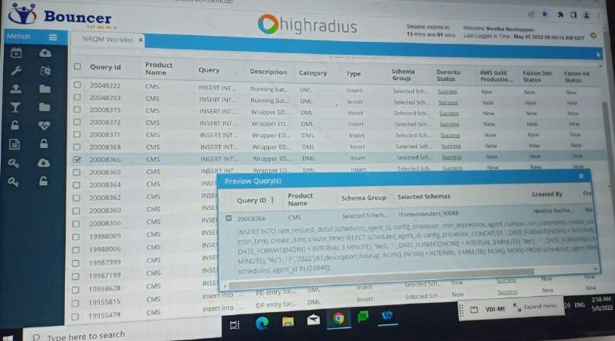

**Figure 5.3.6.1 Preview of a ram request query in bouncer**

## 5.4 GENERATION OF WORKLIST

After running the agents, a worklist is generated where the client can keep track of defaulters and perform different actions on them.

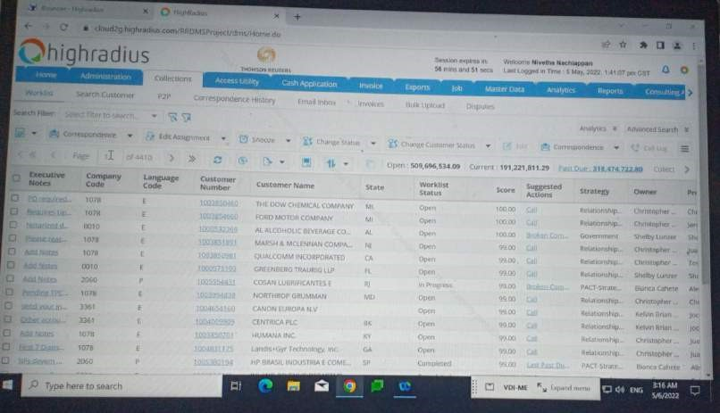

### Figure 5.4.1 Snippet of the worklist generated for Thomson Reuters company

Interesting actions that can be performed on the defaulter are:

1. Snooze – When applied to a defaulter, it removes him from the worklist for the set amount of time and is reflected in the worklist only when that period is over. For example, he would have promised to pay at a later date and thus until that date arrives, he is the least of the client’s concern.

1. Edit Assignment – This comes into play when we suddenly want to change the person following up on a particular defaulter. Sometimes we want to also escalate certain defaulters to the higher ups.

1. Change Customer Status – As is self-explanatory in its own terms, with each interaction, the customer status changes when it comes to his overdue payments. He might have promised to pay in a certain number of days or has already paid and can be removed from the worklist.

**CHAPTER 6: OTHER CLOUDS MEANT FOR LARGE ENTERPRISE**

## 6.1 INTRODUCTION TO SERVICES OFFERED

HighRadius provides autonomous finance through a cloud based system that leverages AI, Robotic Process Automation, Natural language processing etc. as features in accounting and finance.

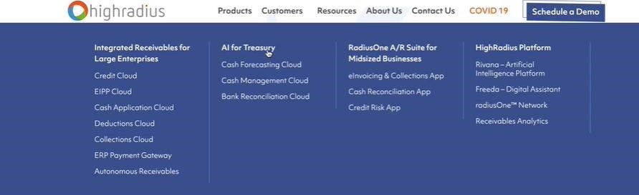

### Figure 6.1.1 HighRadius Products available as of today

As seen in the above diagram, there are the various clouds functioning in the company. As interns, we work with large enterprises and thus all of us were assigned to five clouds primarily.

The five clouds include the Credit Cloud, EIPP Cloud, Cash Application Cloud, Deductions Cloud and Collections Cloud.

As seen in the figure below, we as interns contribute to the autonomous receivables. In simple words, we help businesses collect payments for the goods delivered to their customers and also keep track of their defaulters and take necessary actions to extract fines and payment of goods. We also write-off certain customers in extreme cases.

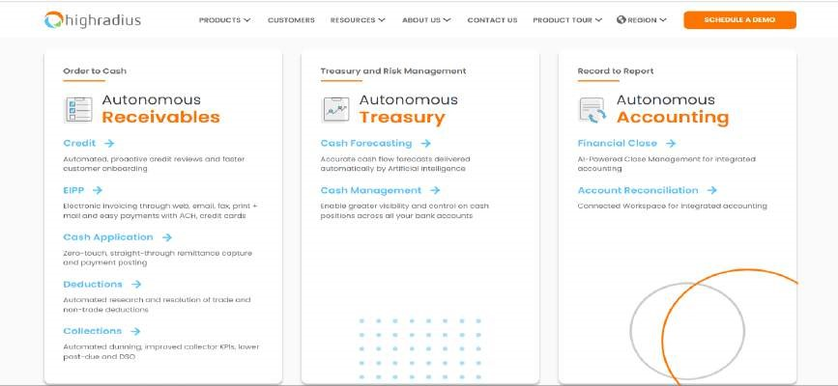

**Figure 6.1.2 Autonomous Finance for the office of CFO**

## 6.2 CREDIT CLOUD

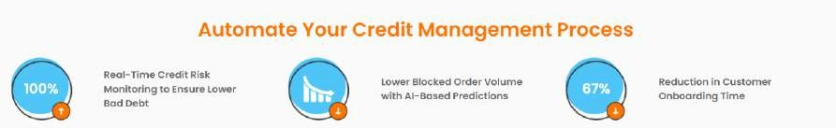

### Figure 6.2.1 Credit Cloud Features

The credit cloud is a software that mitigates risk with real time credit visibility.

It helps lower bad debt by tracking the customers' payment behaviours and rescoring customers based on real time credit risk alerts.

It also leverages AI to predict blocked orders and make better credit decisions.

With such a comprehensive software thus, the company is able to capture complete and accurate credit data reducing the on boarding time to close to 67%.

It tracks changes in credit risk and payment behaviour.

## 6.3 EIPP CLOUD

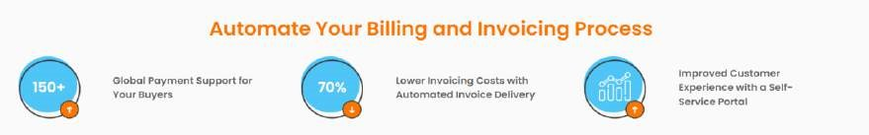

### Figure 6.3.1 EIPP Cloud Features

The EIPP cloud is a global e invoicing and payment software.

It enables frictionless billing and payments globally through auto invoice delivery and selfserve payment portals.

It provides around 150 plus payment methods.

It also provides support for cross border payments.

It lowers the invoicing costs with automated invoice delivery by about 70 percent as it autogenerates invoices through emails, postal mail and fax.

The invoices are also auto-customised based on branding requirements.

It also boasts a self-service portal which is user friendly.

## 6.4 CASH APP CLOUD

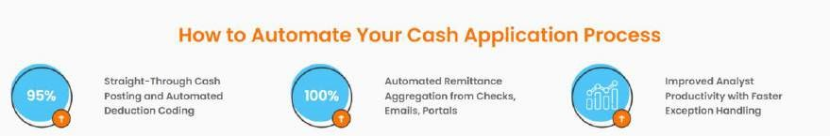

### Figure 6.4.1 Cash App Cloud Features

The Cash App Cloud is the third cloud in the five cloud process to achieve a successful O2C management.

This cloud leverages AI to apply cash accurately even with an incomplete or inaccurate invoice number.

It auto-matches invoices to payments in complex business scenarios such as parent child relationships.

It also auto-extracts remittances from the email body and also auto generates invoice data securely from customer web portals.

This cloud also amazingly leverages AI based cash application technology to predict invoices as missing remittances.

## 6.5 DEDUCTIONS CLOUD

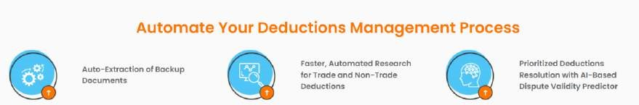

### Figure 6.5.1 Deductions Cloud Features

The Deductions cloud is an AI based deduction management software.

This cloud helps reduce days’ deduction outstanding and improves the net recovery rate of the client company.

It leverages RPA to auto aggregate claims, proofs of deliveries and bill is lading from emails, customer and carrier portals.

It automatically offsets deductions with credits based on business rules.

## 6.6 SIDE NOTE ABOUT COLLECTIONS CLOUD

The final cloud, in use for large enterprises, is the collections cloud to which I was assigned

to.

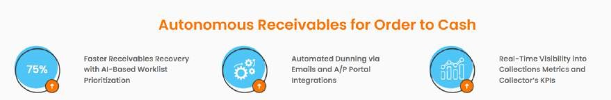

**Figure 6.6.1 Collections Cloud Features**

This cloud is explained in detail in the first chapter.

**CHAPTER 7: CONCLUSION**

## 7.1 SPECIAL MENTIONS

The journey of being associated with HighRadius has been one hell of a ride.

From misunderstandings to the thrill of delivering projects that exceed expectations both in terms of quality and time management, I have experienced it all.

But nothing would have been possible without my mentors, Geetika Batra and Ayesha Mogal. They have guided me when I needed them the most.

I revere them as role models. The experience I have gained through them and my fellow interns have brought about substantial changes in my character for the good.



### Figure 7.1.1 Geetika Batra, Training Period Mentor



**Figure 7.1.2 Ayesha Mogal, Project Mentor**

## 7.2 NOTE TO SELF

There had been days I wanted to give up because of the work pressure.

But those are the days I understood the power of family and friends who had been there to motivate me since day 1.

I came to imagine the stress office-goers experience on a daily basis and have turned towards yoga and self-care to combat the stress.

Nevertheless, I am extremely grateful for the experience.

**REFERENCES**

[1][https://www.highradius.com/about/company-overview/#](https://www.highradius.com/about/company-overview/)

[2]<https://www.highradius.com/culture/>

[3]<https://www.highradius.com/software/integrated-receivables/credit-management/>

[4]https://www.highradius.com/software/integrated-receivables/eipp-automation/

[5]https://www.highradius.com/software/integrated-receivables/cash-application/

[6]https://www.highradius.com/software/integrated-receivables/deduction-management/

[7]https://www.highradius.com/software/integrated-receivables/collections-management/

[8]<https://highradius.skilljar.com/>

[9]https://docs.google.com/spreadsheets/d/1M_brSkbsoixrtrvud3iKeT5zfyrbPkSC/edit?usp= sharing&ouid=103257866993310978543&rtpof=true&sd=true

[10]<http://duronto-uat32.highradius.com/RRDMSProject/signin.do>

[11]<http://bouncer.highradius.com/Bouncer/displayLogin.do>

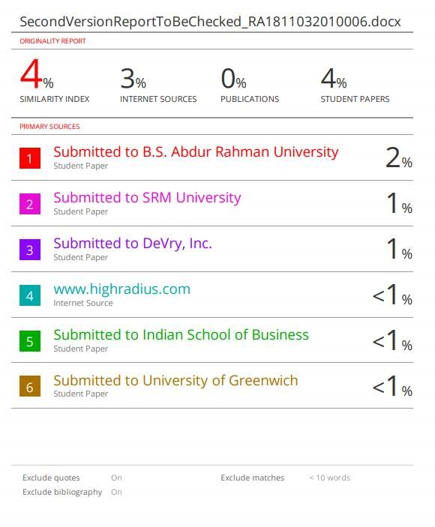

|  |  |  |
| --- | --- | --- |
| **SRM INSTITUTE OF SCIENCE AND TECHNOLOGY**  **(Deemed to be University u/s 3 of UGC Act, 1956)** | | |
| **Office of Controller of Examinations** | | |
| REPORT FOR PLAGIARISM CHECK ON THE SYNOPSIS/THESIS/DISSERTATION/PROJECT  REPORTS | | |
| 1 | Name of the Candidate  **(IN BLOCK LETTERS)** | **NIVETHA N** |
| 2 | Address of the Candidate | **266,KILPAUK GARDEN ROAD,TRIDENT APARTMENTS,BLOCK B,B5,KILPAUK,CHENNAI-10**    **Mobile Number: 9940060673** |
| 3 | Registration Number | **RA1811032010006** |
| 4 | Date of Birth | **05/02/2000** |
| 5 | Department | **CSE-IOT** |
| 6 | Faculty | **Mr. K. C. PRABHU SHANKAR** |
| 7 | Title of the Synopsis/ Thesis/Dissertation/Project | **HIGHRADIUS INTERNSHIP- CONSULTANCY TRACK** |
| 8 | Name and address of the Supervisor /  Guide | **Mail ID: kayalvij@srmist.edu.in Mobile Number: 9884496212** |
| 9 | Name and address of the Co-  Supervisor  / Co- Guide (if any) | **NIL** |
| 10 | Software Used | **TURNITIN** |

|  |  |  |
| --- | --- | --- |
| 11 | Date of **Verification** | 10 May 2022 |

|  |  |  |  |  |
| --- | --- | --- | --- | --- |
| 12 | Plagiarism Details: (to attach the final report) | | | |
| Chapter | Title of the Chapter | Percentage of  similarity index (including selfcitation) | Percentage of  similarity index (Excluding selfcitation) | % of plagiarism after excluding Quotes,  Bibliography, etc., |
| 1 | WHY COLLECTIONS CLOUD | <1% |  | <1% |
| 2 | ACCOUNTING BASICS USED IN WORK  CYCLE | 1% |  | 1% |
| 3 | **BAGGING THE INTERNSHIP** | 0 |  | 0 |
| 4 | **TRAINING PERIOD** | 0 |  | 0 |
| 5 | **BRIEF OF MY WORK AS A CONSULTANT** | 2% |  | 2% |
| 6 | **OTHER CLOUDS MEANT FOR LARGE**  **ENTERPRISE** | 1% |  | 1% |
| 7 | **CONCLUSION** | 0 |  | 0 |
| I / We declare that the above information have been verified and found true to the best of my / our knowledge. | | | | |
| Signature of the Candidate | | Signature of the Supervisor / Guide | | |
| Signature of the Co-Supervisor/Co-Guide | | Signature of the HOD / DRCC Chairperson | | |